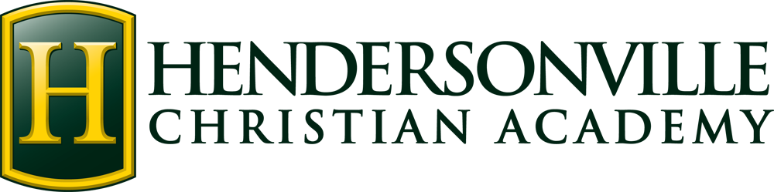

**Kindergarten Classroom Supply List**

(Bring All Items to Open House)

1 King James Version Bible

1. Backpack (large enough to hold a 9 x 12 folder) **

3 Boxes of **24 count** Crayola crayons in classic colors

1 Pair of **blunt tip** Fiskars scissors **

6 Dry erase markers

2 Elmer’s Glue Sticks

1. Pack Classic Colors 10 Count Washable Markers

1 Mead **Primary Journal Stage 3 K-2** (Wal-Mart)

3 Boxes of Kleenex

1 Container of baby wipes (unscented)

1. Package Stickers
2. Box of Ticonderoga #2 pencils

2 Rolls of paper towels

1. Box of Fruit Snacks
2. Bag of Candy
3. Plastic Black Folder (2 pocket)
4. Paper Mate Pink Pearl Eraser (medium or large)

1 Whiteboard (lined on one side, blank on the other)

***\*\*Please label these supplies with your child’s name.***

**Spanish Class Supplies**

1. Two-pocket Folder – label with name and grade level (any color)

1 Pack of Colored Pencils

**Art Class Supplies**

1. 1” **Black** three-ring binder (with clear front pocket to add a cover sheet)

1 Pack of page protectors