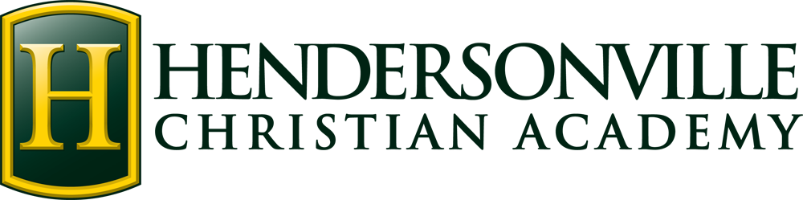

**First Grade Supply List**(Bring All Items to Open House)

1 King James Version Bible*

1 Backpack (large enough to hold a 9 x 12 folder)*

1 Box of **16 count** Crayola crayons in Classic colors

1 Pack Crayola **Classic 12 count** Colored pencils

1 Pair of **blunt tip** Fiskars scissors*

1 12-inch ruler with inches and centimeters*

1 Pack Dry erase markers

1 Small Dry Erase board (approx. 8x10 size)

2 Boxes of Kleenex

1 Bag of candy

1 Box of quart-size Ziploc bags

1 Crayon/pencil box

2 Rolls of paper towels

2 Glue sticks

1 Box of pencils

***\*Please label these supplies with your child’s name only.***

**Spanish Class Supplies**

1 Two-pocket Folder – label with name and grade level (any color)

1 Pack of colored pencils

**Art Supplies**

1 1” **Black** three-ring binder (with clear front pocket to add a cover sheet)

1 Pack of page protectors